Job 4

Aim: To create a flowchart in Microsoft Word illustrating the process of federated learning.

Theory:
Flowcharts are diagrams that represent a workflow or process. They use a set of standard symbols to depict various steps, decisions, and actions, connected by arrows that show the flow and sequence. In Microsoft Word, a Drawing Canvas (Insert > Shapes > New Drawing Canvas) is a useful tool for creating flowcharts, as it groups all the elements together, making them easier to move and resize as a single object.
The flowchart below illustrates the concept of Federated Learning. This is a machine learning approach that trains an algorithm across multiple decentralized devices or servers holding local data samples, without exchanging the data itself.
Steps for Creation:
- Insert a Drawing Canvas: Go to the "Insert" tab, click on "Shapes," and select "New Drawing Canvas" at the bottom of the menu. This will create a bordered area to build your flowchart within.
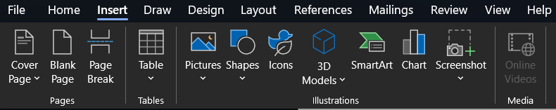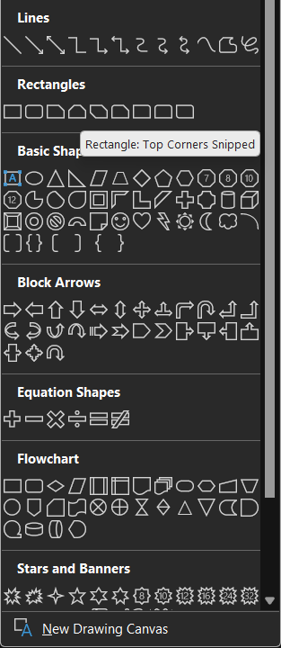
Figure 1 Inserting a drawing canvas
- Create the Central Server: From the "Shapes" menu, select the "Cloud" shape under "Basic Shapes." Draw it at the top-center of the canvas and add the text "Central Server."
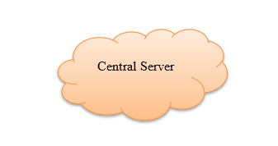
Figure 2 Inserting Cloud Shape for Central Server
- Add Client Areas: Below the server, on the left and right, draw two large "Oval" shapes. Add text boxes inside them labelled "Area A" and "Area B."
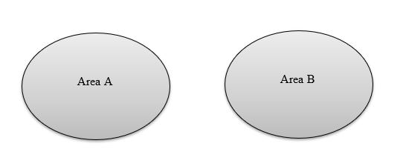
Figure 3 Adding Client Areas
- Represent Data Samples: Inside each oval, insert smaller shapes like circles to represent the "Different samples". Use the brace shape from "Basic Shapes" to group them and add a text box with the label "Different samples" underneath each area.
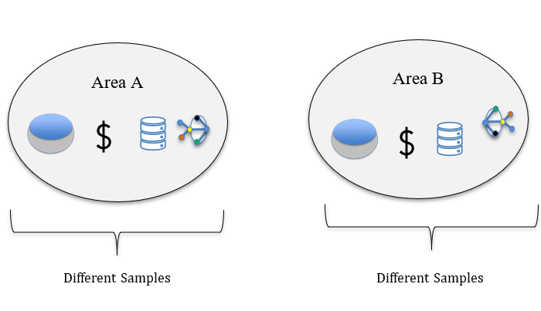
Figure 4 Adding Data Samples
- Illustrate Aggregation: Between the central server and the two areas, draw a few small, filled circles to represent the "Aggregation" process.
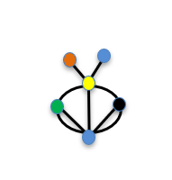
Figure 5 Representing the aggregation process
- Draw Connecting Arrows:
  - Use the "Line Arrow" shape to draw lines from "Area A" and "Area B" pointing upwards towards the "Aggregation" point.
  - Draw arrows from the "Aggregation" point to the "Central Server." Add a text box next to these lines and label it "Local model."
  - Draw an arrow from the "Aggregation" point downwards and label it "Global model."
  - From the "Global model" line, draw arrows pointing to both "Area A" and "Area B."
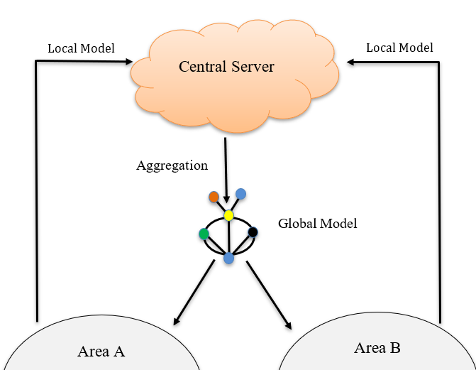
Figure 6 Adding arrows and labels
- Add the "No Exchange" Symbol: Between "Area A" and "Area B," insert an "Oval" shape. Select the "Line" shape and draw it diagonally through the oval. Select both the oval and the line, right-click, and choose "Group" to combine them.
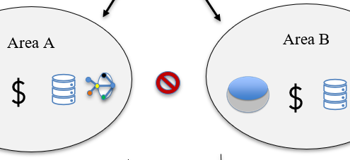
Figure 7 Adding the No Exchange Symbol
- Finalize Formatting: Adjust the colours, line styles, and text fonts using the "Shape Format" tab to complete the flowchart. Select all the shapes on the canvas, right click, and choose “Group” to combine them.
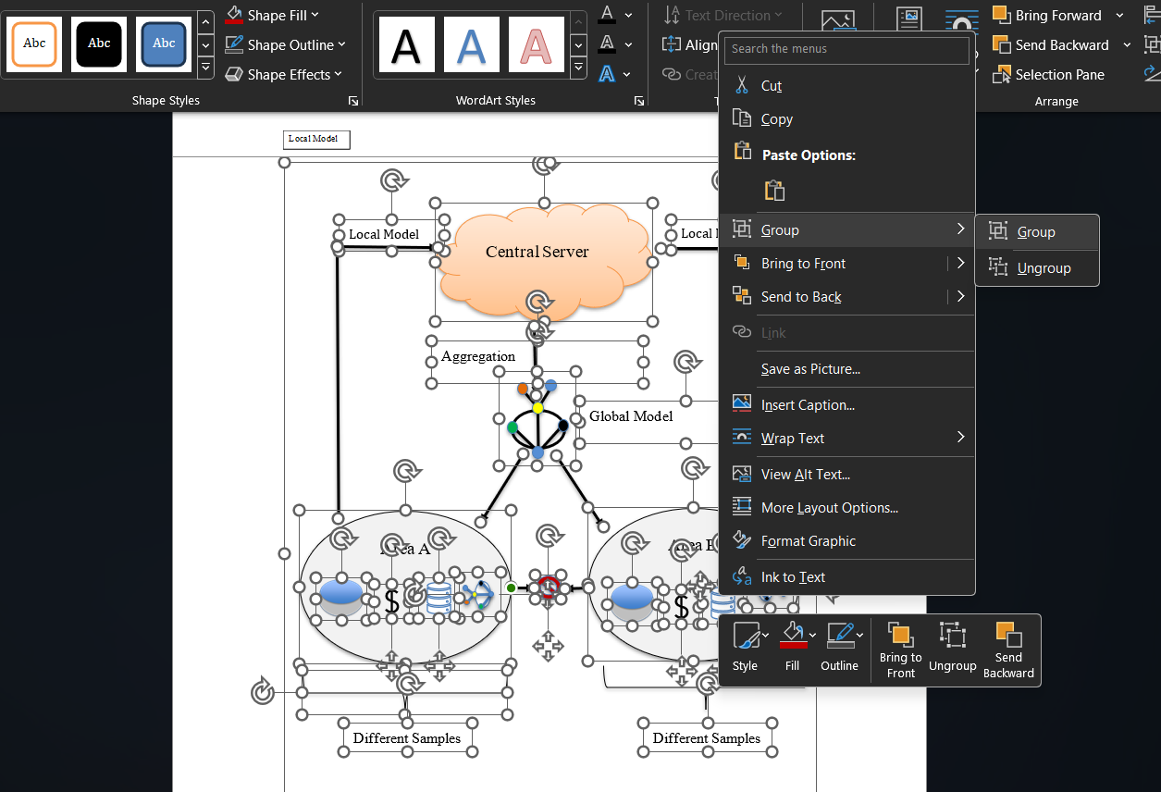
Figure 8 Grouping all the shapes together





Aggregation
Global Model
Local Model
Local Model
Central Server
Area A

Area B

Different Samples
Different Samples

Figure 9 Final Figure

